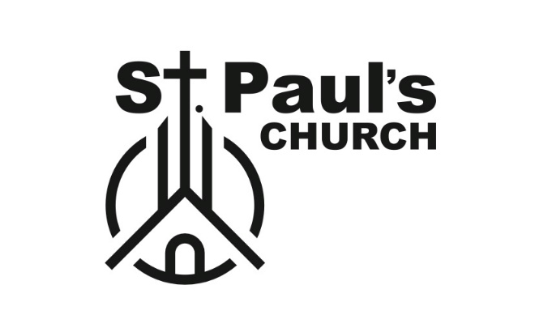

BYLAWS of St. PAUL’S CHURCH

ARTICLE 1
NAME AND PURPOSE
Name: This congregation of believers shall be known as St. Paul’s Church. The church is incorporated as a non-profit corporation under the laws of the State of Virginia.
Purpose: This congregation is organized as a church exclusively for charitable, religious, and educational purposes within the meaning of section 501(c)(3) of the Internal Revenue Code (IRC) of 1986, for such purposes including, but not limited to, proclaiming the gospel of the Lord Jesus Christ; establishing and maintaining religious worship; educating believers in a manner consistent with the requirements of Holy Scripture, and maintaining missionary activities in the United States and around the world.
ARTICLE 2
STATEMENT OF FAITH

2.1 The Statement of Faith does not exhaust the extent of our faith. The Bible is the sole and final source of all that we believe. We do believe, however, that the Statement of Faith accurately represents the teachings of the Bible and, therefore, is binding upon all members, staff, and volunteers. All literature, whether print or electronic, used in the church shall be in complete agreement with the Statement of Faith. All activities permitted or performed in any facilities owned, rented, or leased by St. Paul’s, or engaged in by any member of the church staff (volunteer or paid), and all decisions of the administration of this church shall not conflict with the Statement of Faith. In all conflicts regarding interpretation of the Statement of Faith, the pastor and Church Executive Committee, on behalf of the church, have the final authority.

  - Beliefs on Doctrine:

We believe in the historical creeds of the church; Wesley’s General Rules and the Statement of Doctrine found in the Congregational Methodist Church (CMC) current Book of Discipline.

Additional Religious Beliefs. Refer to Article 5, Section 2, paragraph 655 of the current CMC Book of Discipline.

ARTICLE 3
MEMBERSHIP

3.1 Qualifications for Membership: Members of the church are those members who were previously members of St. Paul’s United Methodist Church and new members of St. Paul’s Congregational Methodist Church. Those seeking new membership must:
- Attend a pre-membership class led by a member of the pastoral staff or appointee in which they will review the church’s Statement of Faith, bylaws, general practices and policies, and expectations of members.
- Be interviewed by the pastor, pastoral staff and/or Church Executive Committee to ensure they fully subscribe to the Statement of Faith contained herein and agree to submit to the authority of the church and its leaders.
- Membership will be granted upon the recommendation of the pastor and a majority vote of the Congregation, and upon compliance with any one of the following conditions:
- By baptism at this local church.
(2) By letter of transfer from another Bible-believing church of like faith and practice, or other written statement of good standing from the prior church if the applicant has been baptized; or by testimony of faith, having been baptized in another Bible-believing church of like faith and practice.

3.2 Privileges of Membership:

- Only members of at least sixteen years of age at a duly called meeting of the church shall be entitled to vote. There shall be no proxy or absentee voting. The eligible members of the church may exercise voting privileges, unless limited by these bylaws.
- This congregation functions not as a pure democracy, but as a body under the headship of the Lord Jesus Christ and the direction of the pastor, as the under-shepherd, with the counsel of the Church Executive Committee. Determinations of the internal affairs of the church are ecclesiastical matters and shall be determined exclusively by the church’s rules and procedures. The pastor and Church Executive Committee shall oversee and/or conduct all aspects of the church. The Church Executive Committee shall give counsel and assistance to the pastor as needed.
- Membership in this church does not afford the members with any property, contractual, or civil rights based on principles of democratic government. The general public is invited to all of the church’s worship services; however, the church property remains private property. The pastor or individual designated by the Church Executive Committee has the authority to suspend or revoke the right of any person, including a member, to enter or remain on church property. If after being notified of such a suspension or revocation, the person enters or remains on church property, the person may, in the discretion of the pastor or person designated by the Church Executive Committee, be treated as a trespasser.
- A member may inspect the prepared annual financial statement of the church and the minutes of church and committee meetings, provided he/she makes a written request at least 15 business days prior to the Executive Committee stating the specific records requested and the reason for the request. Requests may be denied if it is deemed to be frivolous by a majority vote of the Church Executive Committee. Church Executive Committee meeting minutes and other meeting minutes involving privacy interests such as, but not limited to, donor records, lists of names and addresses of church members, individual benevolence, individual salaries, health information, background checks, and social security numbers, are exempt from this provision and are not subject to inspection without a court order. Members may not copy or take digital images or records of any ministry record without authorization from the pastor or chairman of the Church Executive Committee.

3.3 Termination of Membership. The membership of any individual member may automatically terminate without notice if:
- The member in question has not attended a regular worship service of the church in the preceding twelve months. This provision may be waived at the discretion of the pastor and the Church Executive Committee upon the showing of good cause.
- The member advocates doctrine that is in direct contravention to the church’s Statement of Faith.
- The member becomes a member of another church.
- The member files a lawsuit in violation of the Statement of Faith.
- The member dies.
- For any memberships terminated in accordance with the above provisions, the church may send a letter of membership termination.

3.4 Transfer or Resignation of Membership. Members, not under the disciplinary process of Article 3, may request a letter of transfer be sent to another church.

3.5 Discipline of A Member. Disciplinary actions may be considered in accordance with the Book of Discipline, Article IV. Judicial Procedures.

ARTICLE 4
OFFICERS

4.1 Designation of Corporate Officers: Corporate Officers are as designated in the Articles of Incorporation of St. Paul’s Church. Corporate Officers elect their own successors, as per the Virginia State Corporation Commission, but must be members of St. Paul’s Church in good standing.

4.2 Church Officers: Church officers are the members of the Church Executive Committee, which include the Lead Pastor, Executive Committee Chair, Executive Committee Vice Chair/Finance Lead, Recording Secretary/HR Lead, Treasurer, and any other officers the church deems necessary. The church shall have nine Church Executive Committee voting members. The Visitation Pastor and the Treasurer will serve as non-voting members of the Executive Committee.

4.3 Eligibility for Church Officers:
- The church shall not install or retain an officer who fails to adhere to or expresses disagreement with the Statement of Faith set forth in Article 2.
- The Church Executive Committee Chair and pastor must initially and thereafter annually approve all church officers to continue in their offices.
- Members of the same household (spouse, parent, sibling) will not be eligible as an officer while another family member is serving as an officer.
- Only church members are eligible for election or appointment to any church office or position. Employees of St. Paul’s Church are not eligible for election. The Visitation Pastor and Treasurer serve as non-voting members of the Executive Committee while employed.

  - The annual election of officers, other than the senior and other pastors, by the church membership shall occur during the month of November at the annual church business meeting. Officers of the church must be elected by a majority of the eligible membership present at a regular or special church business meeting. The Church Executive Committee in consultation with the pastor, from time to time as he deems appropriate, may appoint other church officers, subject to a confirmation vote by a majority of the eligible church membership, present and voting at any regular or special church business meeting. Members may submit to the pastor and the Church Executive Committee nominations for officers. The Nominating Committee with the pastor shall provide a slate of nominations for all general elections of officers.

4.5 Terms of Service for Officers:
- The relationship between the senior pastor and the church shall be permanent unless dissolved at the option of either party by the giving of ninety days’ notice, or less by mutual consent. The severance of the relationship between the pastor and the church may be considered at any regular or special church business meeting, provided notice of the meeting is given from the pulpit to the church two Sundays prior to the meeting. A majority of the eligible members present, and voting shall be required to remove the pastor from office. Disciplinary removal of the pastor from office automatically terminates his or her membership.
- Any other Church Executive Committee member may be removed from office, before his or her term expires for any reason stated or unstated, upon motion by any Church Executive Committee member and an affirmative majority vote of the other Church Executive Committee members at a duly called meeting of the Church Executive Committee. No congregational vote is necessary for Church Executive Committee member removal. This process is intended to protect the personal or private information of any Church Executive Committee member being removed from the office.
- The term of service for all offices and positions in the church, except the pastor and other staff members, shall be one year, at the expiration of which the officers may be re-elected or re-appointed.
- A vacancy occurring in any office or on the Church Executive Committee, except in the case of the pastor, may be filled at any regular church business meeting by a majority vote of eligible members present.

4.6 Calling a Pastor: Upon the resignation, death, or dismissal of the pastor, the church shall seek a candidate who subscribes to the Statement of Faith and bylaw provisions of the church. The church shall abide by the following guidelines for calling a pastor:
- The Church Executive Committee shall select a pulpit committee to consist of all Church Executive Committee members and up to five other members elected by a majority vote of the Church Executive Committee. The pulpit committee shall interview potential candidates and will only consider those who completely subscribe to the Statement of Faith and who have read these bylaws. The Pulpit Committee will utilize all resources available, including immediate consultation with the Headquarters of the Congregational Methodist Church.
- The interview process for selecting a pastoral candidate shall include, at a minimum, the following: a background check, a credit check, reference checks, and a detailed application that explains the candidate’s philosophy of ministry and their position on issues of doctrinal significance.
- Upon a majority vote of the pulpit committee, the committee will formally announce the candidate to the church. He or she must preach at least one regularly scheduled church service, and be available for a church-wide question and answer time prior to being voted upon by the church membership.
- Notice from the pulpit must be given two consecutive Sundays prior to a formal candidate’s preaching service(s), and two consecutive Sundays prior to the church membership vote.
- The candidate must be elected as pastor by a majority vote of members present and qualified to vote. This vote shall be taken by a written, secret ballot at a meeting where the candidate is not present.

ARTICLE 5
DUTIES AND POWERS OF OFFICERS

5.1 The Pastor:
- The pastor shall preach the Gospel regularly and is at liberty to preach the whole counsel of the Word of God. The pastor shall administer the ordinances of the church; act as moderator, or appoint a moderator, at all church meetings for the transaction of church matters; supervise the teaching ministries of the church; and watch over the spiritual interests of the membership. In all conflicts regarding interpretation of Scripture, the pastor is the final authority. The pastor shall administer the Sacraments of Holy Communion and Baptism and regularly affirm the importance of these to the membership. The pastor shall perform and officiate the acts of funeral, memorial services and marriage while providing pastoral care.
- The pastor and Church Executive Committee, on behalf of the church, shall establish committees.
- The pastor will determine the appropriateness of the use of all church property and the organizations or persons permitted to use the property.
- The pastor is responsible to fill the pulpit for each regularly scheduled church service and other special services.
- The pastor and the Church Executive Committee are responsible to establish mandatory safety and security procedures for all ministries and programs. There will be a zero-tolerance policy regarding abuse of minors, and any reasonable suspicions of child abuse alleged to be perpetrated by staff, volunteers, members, or non-members will be reported to the appropriate law enforcement or child abuse prevention authorities. The pastor or his or her designee is responsible for providing yearly child abuse prevention training for all staff and volunteers.

5.2 Church Deacons. Deacons shall aid the pastor under his leadership. They are elected by the church to serve in the ministry and ordained by the pastor. Deacons may serve on any committee or board but may not vote. Ordination is for life, but the church may set the term of service.

  - The Church Executive Committee:
- The Church Executive Committee shall assist the pastor in promoting the spiritual welfare of the church, in conducting the church services, and in performing all other work of the church. The Church Executive Committee shall consider benevolence needs, disburse the benevolence fund in cooperation with the pastor, and assist the pastor in all other evangelistic efforts of the church. The Church Executive Committee shall assist the pastor in caring for the administrative needs of the church’s various ministries. They shall provide the pulpit supply and choose a moderator for church meetings if the pastor is unavailable or the office of pastor is vacant. Upon the death, resignation, or dismissal of the pastor, the Church Executive Committee may appoint a pulpit committee.
- The Church Executive Committee shall include a Chairperson, a Vice Chairperson, and a Recording Secretary. The *Vice Chairperson will be the Finance Lead. The Recording Secretary will be the Human Resources Lead.
- The Church Executive Committee shall, in conjunction with the pastor, conduct an annual ministry liability and safety review of the following policies and/or topics: child protection, including but not limited to worker screening procedures, child abuse reporting procedures, and worker training on child abuse prevention; building safety; security measures; insurance; financial accountability; transportation; sexual harassment; policies listed in IRS Form 990, including a whistleblower policy, a document retention and destruction policy, and a church financial investment policy (if applicable).
- Each Church Executive Committee member shall review the bylaws annually and will bring suggested changes to a meeting of the Church Executive Committee that has been designated for the purpose of reviewing the bylaws.
- Corporate Officers are as designated in the Articles of Incorporation of St. Paul’s Church. Corporate Officers elect their own successors as per the Virginia State Corporation Commission. In addition to the various powers specifically granted by the Corporate Board of Directors under these bylaws, the Corporate Board of Directors has the authority to exercise the following powers, upon authorization by a majority vote of the eligible members at a duly called business meeting:
- To purchase, lease, or otherwise acquire real and personal property on behalf of the church, and to take real and personal property by will, gift, or bequest on behalf of the church.
- To sell, lease, or otherwise dispose of, and to mortgage, pledge, or otherwise encumber the real and personal property of the church; to borrow money for the purpose and use of the church; to cause to be executed, issued, and delivered for the indebtedness, in the name of the church, promissory notes, bonds, debentures, or other evidence of indebtedness; and to secure repayment by deeds of trust, mortgages, or pledges.
- To exercise all powers necessary for the dissolution of the church corporation.
- To maintain the duties of loyalty to the church, confidentiality of church information, and fiduciary care regarding church finances, and a spiritual duty to pray for and support the church with their time, talents, and treasures.
- All powers of the Church Board of Directors shall be compatible with the laws of the State of Virginia.

  - Church Secretary: The church secretary, along with any assistant, co-officer, or church clerk, shall:
- Certify and keep at the church’s office the original bylaws or a copy, including all amendments or alterations to the bylaws; minutes of meetings; the membership roll; baptisms; and records of any special events which are of historical interest to the church. The secretary shall deliver all such documents to his or her successor upon leaving office.
- Maintain, file and preserve minutes of all church business and Church Executive Committee meetings, including the time and place of holding, the notice given, the names of those present unless a church-wide meeting, and an accurate record of all church business approved at each meeting. A copy of these minutes shall be kept as a permanent record of the church and shall be made available at all reasonable times to proper person on terms provided by law and pursuant to these bylaws.
- See that all notices are duly given in accordance with the provisions of these bylaws. In case of the absence or disability of the secretary, or his or her refusal or neglect to act, notice may be given and served by the pastor or by the chairman of the Church Executive Committee.

5.5 Corporate Secretary / Registered Agent. Sign, certify, or attest documents as required by law and ensure reports, statements, certificates, and all other documents and records required by law are properly maintained and filed.

5.6 Treasurer. The church treasurer, together with any assistant or co-officer, is responsible for:
- Promptly counting cash funds with two unrelated individuals (tellers) and recording all received amounts. If two tellers are not available, the treasurer may serve as a teller.
- Depositing all counted funds into the proper bank/financial accounts.
- Maintaining a record of individual giving for all donations, offerings, contributions, and gifts, and safeguarding the confidentiality of these records.
- Issuing an official receipt to each contributor at the end of the fiscal year.
- Maintaining the records of all financial transactions of church funds. The treasurer will make monthly reports of itemized income, disbursements, transfers and the financial position of the church, including budget execution as requested by the pastor and/or the Church Executive Committee.
- *The Vice Chairperson, as the Finance Lead of the Executive Committee, shall identify a person and process for accounts reconciliation and present the financial report during regular business meetings.

5.7 Trustees: The Board of Trustees is comprised of two to eight members who are elected annually, plus the Chairman and will serve under the authority of the Corporate Board of Directors and oversee all real estate needs including legal issues, construction, repairs, and general upkeep. The Board of Directors Vice Chair will serve as the Chairman of the Trustees.

  - Duties of All Officers:
  - All officers shall prepare a written report of their work for the annual church business meeting and shall surrender all records in their possession to the church secretary at the close of their term of office to be filed as a permanent record of the work of the church. All records are the property of the church and must be kept in the church office.
  - Any officer who neglects his or her duties, as outlined in the bylaws, for a period of three months may be removed from office at the discretion of the pastor, and another chosen as a replacement in accordance with the bylaws.

ARTICLE 6
CHURCH BUSINESS MEETINGS AND MEETINGS OF THE CHURCH EXECUTIVE COMMITTEE

  - Annual Church Business Meeting:
- The annual church business meeting, for the election of officers and the transaction of other business, shall be held on the Sunday preceding the second Monday in November. A quorum shall consist of the eligible members present. Public notice of the meeting shall be given from the pulpit for two successive Sundays immediately preceding the meeting.
- The Senior Pastor shall serve as moderator of church business meetings. In the event of a conflict of interest, the Church Executive Committee Chairman may substitute a moderator.
- The moderator shall determine the rules of procedure according to a sense of fairness and common sense, giving all members a reasonable opportunity to be heard on a matter. The moderator is the final authority on questions of procedure, and his or her decision is final and controlling.
- For any meeting under this article, the moderator, in his or her sole discretion, shall have full and unilateral authority to require nonmembers (or children, if circumstances so warrant) to leave the meeting room and to order the immediate removal of any member or other person present who is deemed by the moderator to be disruptive to the proceedings by act or presence. If the moderator determines that compliance with this order of removal is unsatisfactory, he may, in his or her sole discretion, revoke the disruptive person’s right to remain on the premises and treat the person as a trespasser.
- Under exceptional circumstances Church business meetings, including the annual meeting and special meetings, may be conducted by virtual means for the transaction of business normally conducted during in-person church business meetings. A quorum shall be established by those eligible voting members attending in person or virtually, and voting will be conducted by any means deemed acceptable by the Church Executive Committee. Notice of business meetings and other notice required by these bylaws shall be provided by email, the church website, social media site, text message, and/or other methods deemed by the Church Executive Committee to be most likely to reach church members at least two weeks before the meeting. Such notice satisfies “notice from the pulpit” when that method of notice is otherwise required by these bylaws. Attendance at the meeting without protest shall be deemed waiver of notice.
- The fiscal year of the church shall begin January 1 and end December 31.

  - Church Special Business Meetings: The pastor or the Church Executive Committee may call a special church business meeting by giving notice from the pulpit to the church of such a meeting and the purpose for which it is called at least one Sunday and not less than one week prior to said meeting.

6.3 Voting: Voting at any church business meeting is limited to eligible members in good standing with the church who are physically present at the meeting; an exception to this in-person vote requirement exists if the church is meeting electronically as permitted by these bylaws. Absentee voting is not permitted, and any member who is undergoing church discipline at the time of a vote is not permitted to vote. A majority vote of those eligible members attending the meeting, whether in person or electronically, will constitute the requisite number of votes for passage of amendments and motions, whether by the Church Executive Committee voting at a Church Executive Committee meeting or by the members voting in a church business meeting. The pastor is a voting member of the Executive Committee.

  - Motions: Members who desire to make a motion or subject matter be discussed during an annual, regular, or special business meeting must file a written recommendation with the pastor and Church Executive Committee two weeks prior to the meeting. The pastor and the Executive Committee will consider the proposal and proceed according to their conscience and what they understand to be in the best interests of the church. All motions will be presented by the pastor and/or chair of the Church Executive Committee (or other moderator if the office of pastor is vacant) unless the pastor and/or the Church Executive Committee has delegated authority to another member and/or officer to raise certain motions. No motions will be made from the floor.

  - Meetings of the Church Executive Committee:
- Regular Meetings: Regular meetings of the Church Executive Committee shall be held at such a time and place as the Church Executive Committee determines.
- Special Meetings. The pastor or any two Church Executive Committee members may call a special meeting of the Church Executive Committee at any time, and nothing contained in this article shall be construed as limiting, fixing, or affecting the time or date when a meeting called by action of the Church Executive Committee may be held.
- Notice of Meetings: Notice shall not be required for regularly scheduled meetings of the Church Executive Committee unless there has been a change to the time, date, or location of such regularly scheduled meetings.
- Quorum: A quorum for meetings shall consist of a majority of the Church Executive Committee. If a quorum is not established, the meeting shall be adjourned and rescheduled to a date within ten days of providing proper notice to all Church Executive Committee members. At the reconvened meeting, the members present shall constitute a quorum.
- Roles: At every meeting of the Church Executive Committee, the chairman, or in his or her absence, the officer designated by the chairman or in the absence of a designation, the person (who shall be one of the officers, if any is present) chosen by a majority of the Church Executive Committee members present, shall act as chairman and/or moderator, and shall conduct the meeting in an orderly manner as determined by the chairman. The recording secretary of the Church Executive Committee shall serve as secretary of all meetings, take accurate minutes of Church Executive Committee meetings and promptly deliver approved minutes to the church secretary. In the absence of the recording secretary, the chairperson may appoint another person to act as the recording secretary for the meeting.
- Participation in Meetings: Any Church Executive Committee member may participate in a meeting of the Church Executive Committee in person, or virtually by means of a conference telephone, web-based conference, or similar communications equipment or device by a means all persons participating in the meeting can hear each other at the same time. Participating by such means shall constitute presence in person at a meeting for purposes of determining if a quorum is present.

ARTICLE 7
EDUCATIONAL MINISTRIES

7.1 Purpose: The church believes that the home and church are responsible before God for providing a Christian education. To help fulfill the responsibility of imparting biblical truth and furthering the Great Commission, this church shall establish and maintain an educational program (either a Sunday School and/or a weekday educational program) for the purposes of winning souls to Christ and teaching Bible doctrine, godly worship, and biblical Christian living. To this end, the church shall engage in educational ministries.

7.2 Agreement with Statement of Faith: All educational programs or courses of instruction shall be conducted as an integral and inseparable ministry of the church and shall be taught and presented in full agreement with the Statement of Faith of the church and the inerrant Word of God. The church shall not hire, appoint, or retain any employee or volunteer for its educational programs who fails to adhere to or who expresses disagreement with the Statement of Faith or who adopts or lives a lifestyle inconsistent with the beliefs and practices of the statement of the faith, whether in or out of the classroom.

ARTICLE 8
COMMITTEES

8.1 Committees: The pastor and Church Executive Committee, on behalf of the church, may designate or form committees and may appoint members and/or chairpersons of said committees as considered by the pastor and Church Executive Committee to be in the best interests of the church. These committees may be standing or temporary (special) committees.

8.2 Actions of Committees: Committees have no authority to act on behalf of the corporation. Their primary function is to research, recommend and execute Church Executive Committee approved plans. Committees shall make available all records and materials to the pastor and Church Executive Committee. The Executive Committee may overrule any plans or decisions made by the committee. Each committee will have a secretary who keeps and submits minutes of meetings to the pastor and church secretary for filing with church records. If deemed appropriate by the pastor and Church Executive Committee, the committee secretary, in conjunction with the chair, will submit an annual report to the church of the decisions and plans of the committee.

ARTICLE 9
DESIGNATED CONTRIBUTIONS

The church, in the exercise of its religious, educational, and charitable purposes, may establish various funds to accomplish specific goals. If the church receives a designated contribution for these funds or for any other designated purpose, the church will attempt to honor the designation. All designated contributions shall be deemed advisory rather than legally mandatory in nature and shall remain subject to the exclusive control and discretion of the pastor and the Church Executive Committee. No fiduciary obligation shall be created by any designated contribution made to the church other than to use the contribution for the general furtherance of any of the purposes stated in Article 1.

ARTICLE 10
CONFLICT OF INTEREST POLICY

10.1 Purpose: The purpose of this conflict-of-interest policy is to protect the church’s interest when it is contemplating entering into a transaction or arrangement that might benefit the private interest of an officer or director of the church or might result in a possible excess benefit transaction. This policy is intended to supplement, not replace any applicable state or federal laws governing conflicts of interest applicable to nonprofit and charitable organizations.

10.2 Each officer, employee, or committee member of the church shall, during his or her or her duties on behalf of the church, exercise the utmost good faith in all matters and transactions involving the church and adhere to the highest ethical standards of fiduciary duty to the church. Each officer, employee, or committee member of the church shall endeavor to avoid, to the best of his or her or her ability, any situation which may compromise his or her duty to church because of a conflict of interest with any other entity or person with which the officer, employee, or committee may be involved. Each officer, employee, or committee member shall endeavor to avoid even the appearance of a conflict of interest which may have an adverse effect on the church.

10.3 Duty of Full Disclosure: An officer, employee, or committee member shall disclose relationships and interests which may present a conflict of interest in writing to the Executive Committee immediately when the relationship is formed or upon the officer’s, employees, or committee member’s discovery of the potential conflict of interest. Disclosure shall occur when the personal interests of the officer, employee, or committee member could affect the activities, property, employees, or services of the church. All disclosed information shall be maintained in confidence by the Executive Committee. The Executive Committee shall provide access to financial information, if any, related to the disclosed relationship or transactions only to those people who have reasonable need to know the contents thereof.
10.4 Recusal: When an officer, employee, or committee member has a direct or indirect financial interest in a proposed transaction, the officer, employee, or committee member shall leave the room and shall not participate in the deliberations on the merits of the proposal, or vote.
10.5 The Executive Committee shall consider and evaluate each potential conflict of interest disclosed considering any applicable state or federal laws governing conflicts of interest applicable to non-profit and charitable organizations. The Executive Committee shall approve or authorize the transaction, if at all, only in good faith and without unjustified favoritism, provided the primary beneficiary of the transaction is the church.
ARTICLE 11
BINDING CHRISTIAN ARBITRATION

11.1 Submission to Arbitration: Paid employees of the church must agree to submit to binding Christian arbitration any legal matters within the church that cannot otherwise be resolved, and expressly waive any and all rights in law and equity to bring any civil disagreement before a court of law, except that judgment upon the award rendered by the arbitrator may be entered in any court having jurisdiction thereof.

11.2 Arbitration Procedure: The procedures for arbitration shall be adopted by the Church Executive Committee. This arbitration provision is ecclesiastical and faith-based in nature and is intended to operate under the rules and guidelines of this local church. It is not intended to operate under any state or federal guidelines for arbitration.

ARTICLE 12
TAX-EXEMPTION PROVISIONS

12.1 Private Inurement: No part of the net earnings of the church shall inure to the benefit of or be distributable to its members, trustees, officers, or other private persons, except that the church shall be authorized and empowered to pay reasonable compensation for services rendered and to make payments and distributions in furtherance of the purposes set forth in Article I hereof.

12.2 Political involvement: As prohibited by law, the church shall not participate in or intervene in (including the publishing or distribution of statements) any political campaign on behalf of (or in opposition to) any candidate for public office.

12.3 Dissolution. Upon the dissolution of the church, no part of the organization’s earnings or assets may inure to the benefit of any of its members; and the Church Executive Committee shall, after paying or making provision for payment of all the liabilities of the church, dispose of all assets of the church to such organization or organizations formed and operated exclusively for religious purposes as shall at the time qualify as an exempt organization or organizations under section 501(c)(3) of the Internal Revenue Code of 1986, as the Church Executive Committee shall determine. Assets may be distributed only to tax-exempt organizations that agree with the church’s Statement of Faith.

12.4 Nondiscrimination Policy. The church shall not discriminate against members, applicants for membership, students, or others on the basis of race, color, nationality, or ethnic origin; however, as a religious institution it reserves the right to deny or terminate employment or to deny or terminate any other status of persons whose lifestyle, words, actions or otherwise do not align with the church’s Statement of Faith, standard of conduct or other policies of the church. This policy statement is not intended to waive the ministerial exception or any other exception or exemption to federal, state, or local anti-discrimination laws or regulations.

12.5 Limitation of Activities. Notwithstanding any other provision of these bylaws, the church shall not, except to an insubstantial degree, engage in any activities or exercise any powers that are not in furtherance of the purposes stated in Article I.

ARTICLE 13
AMENDMENTS

13.1 These bylaws may be revised or amended by a majority vote of the eligible members present and voting at any regular church business meeting, provided that said revision or amendment is announced from the pulpit for at least two consecutive Sundays, and at least 10 days before the vote is taken. Proposed amendments or changes must be made available to voting members for review at least one week prior to the meeting at which the vote to amend the bylaws will be taken. Amendments become effective immediately upon a majority vote approving the same.

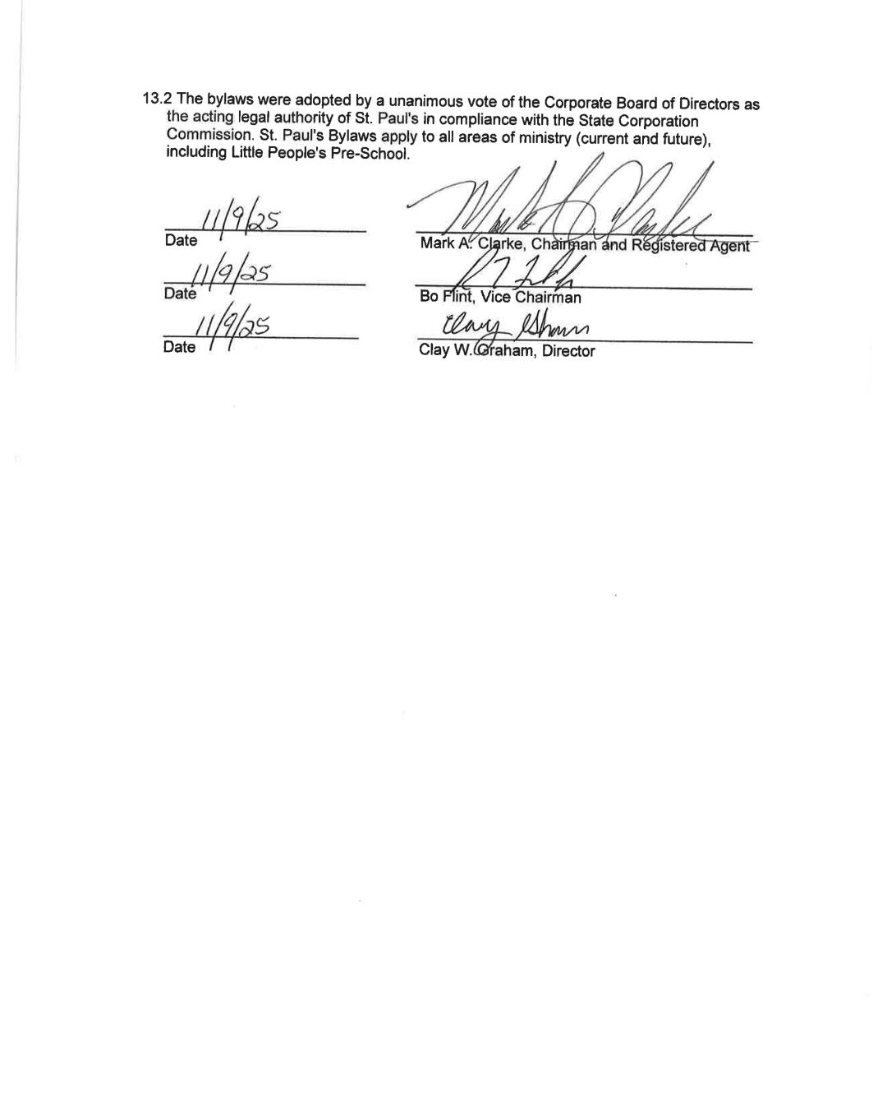
13.2 The bylaws were adopted by a unanimous vote of the Corporate Board of Directors as the acting legal authority of St. Paul's in compliance with the State Corporation Commission. St. Paul's Bylaws apply to all areas of ministry (current and future), including Little People's Pre-School.

______ __________
Date Mark A. Clarke, Chairman and Registered Agent

______ __________
Date Bo Flint, Vice Chairman

___________ ________________
Date Clay W. Graham, Director

